Name ________________ JMJ Date _____________
Period _______________ Physical Science

Determine whether the statement/picture explains Boyle’s Law or Charles’ Law.

___________________1) Stepping on a balloon to make it pop.
___________________2) A thermometer pops out of turkey.
___________________3) When a nurse gives you a shot using a syringe.
___________________4)After ascending into flight, the chip bags are very “puffy”.
___________________5) Placing a lighter underneath a dented ping pong ball to make it
undented.
___________________6) Soccer balls and basketballs are deflated in the winter.
___________________7) A scuba diver comes to the surface very slowly to prevent injury
such as “the bends”.
___________________8) When you go up in an airplane, your ears hurt.
___________________9) After descending, the water bottle is crumpled.
___________________10) A slightly deflated raft becomes fully inflated/too much after
being outside in the hot sun for a while.

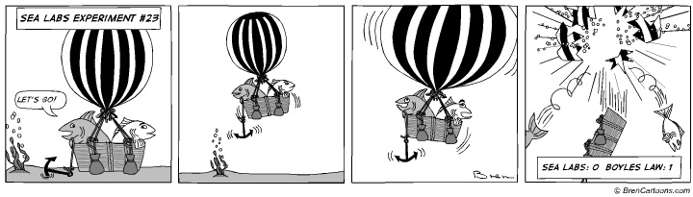

11) What law does this comic strip demonstrate? _____________________________________
Explain: _____________________________________________________________________________
_____________________________________________________________________________________

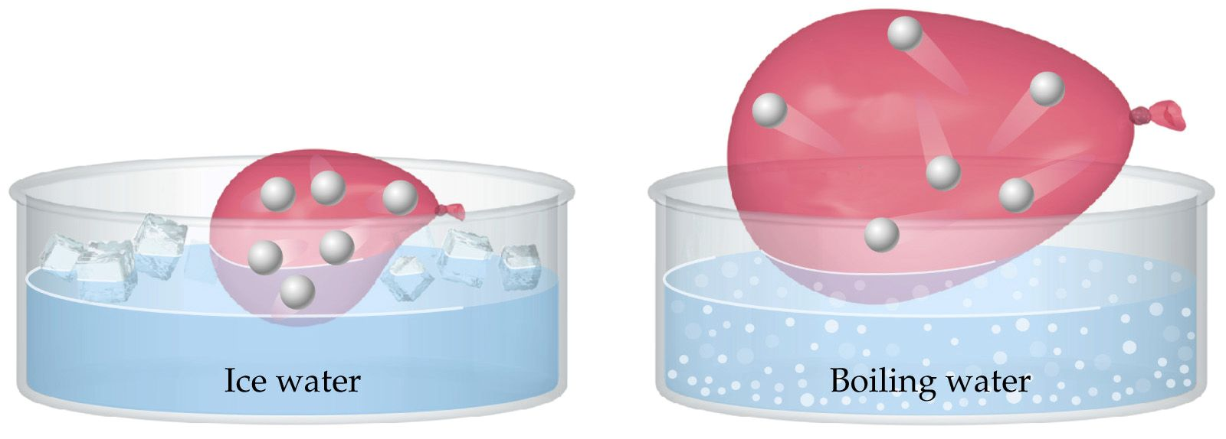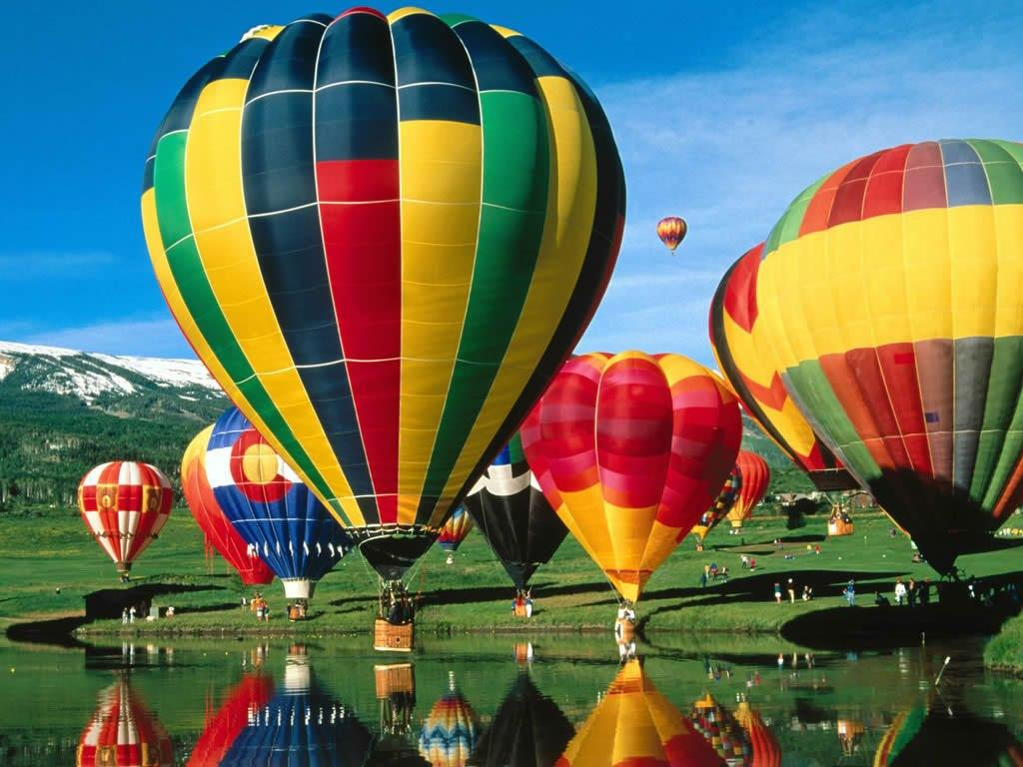

12) Which law do these pictures demonstrate? ______________________________________
Explain: _____________________________________________________________________________
_____________________________________________________________________________________
Name ________________ JMJ Date _____________
Period _______________ Physical Science

Determine whether the statement/picture explains Boyle’s Law or Charles’ Law.

Boyles__________1) Stepping on a balloon to make it pop.
Charles_________2) A thermometer pops out of turkey.
Boyles__________3) When a nurse gives you a shot using a syringe.
Boyles__________4)After ascending into flight, the chip bags are very “puffy”.
Charles__________5) Placing a lighter underneath a dented ping pong ball to make it
undented.
Charles__________6) Soccer balls and basketballs are deflated in the winter.
Boyles__________7) A scuba diver comes to the surface very slowly to prevent injury
such as “the bends”.
Boyles_________8) When you go up in an airplane, your ears hurt.
Boyles__________9) After descending, the water bottle is crumpled.
Charles________10) A slightly deflated raft becomes fully inflated/too much after
being outside in the hot sun for a while.

11) What law does this comic strip demonstrate? Boyle’s Law
Explain: This demonstrates Boyle’s law because as the fish in the balloon ascend, pressure decreases since the column above it gets smaller. With a decrease in pressure, there is an increase in volume. Therefore, the balloon with increase in volume and eventually pop!

12) Which law do these pictures demonstrate? Charles’ Law
Explain: These two pictures explain Charles’ law. In the first picture (left), the ice water has low temperature/kinetic energy, therefore the balloon’s volume decreases as well. The particles in the gas compact together or cuddle together. If the temperature is high, the kinetic energy of the particles moves faster and the particles spread out more. This increases the volume of the balloon or hot air balloon. Makes the hot air balloon rise.

