Name ________________ JMJ Date ____________
Period _______________ Miss Pisciotta

Charles’ and Boyle’s Examples
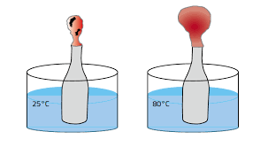
- What law does this image explain? ___________________

- Explain in your own words: ____________________________

_____________________________________________________________

_____________________________________________________________

_____________________________________________________________

_____________________________________________________________
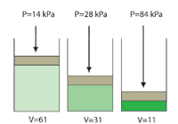
- What law does this image represent?

___________________________

- Is this law directly proportional or inversely proportional?

___________________________
- What law does this image explain? ___________________

- Explain in your own words: ____________________________

______________________________ _______________________________

_____________________________________________________________

_____________________________________________________________

_____________________________________________________________

- What law does this image represent?

___________________________

- Is this law directly proportional or inversely proportional?

___________________________

